A Week in Costa Rica
Retreat and Sacred Sites Tour
June 18th-26th, 2022
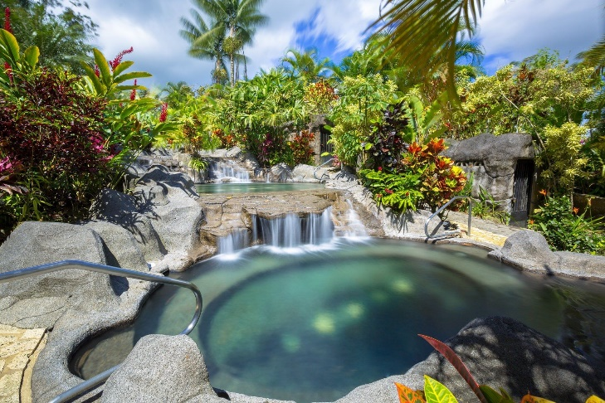
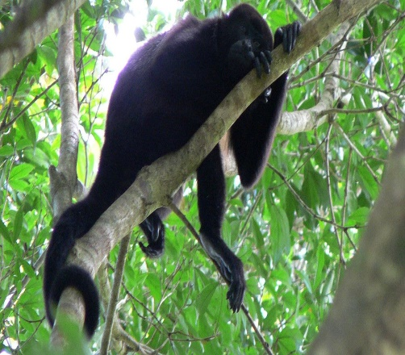
Come join me for a 9 day healing week balancing and bringing into harmony your mind, body, and soul in Costa Rica. We will start our journey in beautiful La Fortuna at a luxury resort, tucked away on 27 acres of lush, rolling landscape, crystalline waters with stunning views of the Arenal volcano. To start the week, we will have a workshop where we will listen to our bodies and heal in the deepest places that we have numbed and buried pain, hurt and density. We will go on journeys connecting to the gentle feminine energies of Costa Rica, where in her arms you have the opportunity to connect to the heart, opening to loving yourself in deeper ways that many have not experienced before. You will have plenty of free time to soak in the 8 natural thermal pools on the property or take a walk in the gardens rich in nature where you might see a local sloth hanging in the tree or a Toucan singing a song. Rejuvenate with an included massage or time just relaxing by the waters. If you want you can add on more healing and rejuvenation at the spa on property, which offers many body treatments and wraps including a detox volcanic wrap or a soothing cocoa treatment.
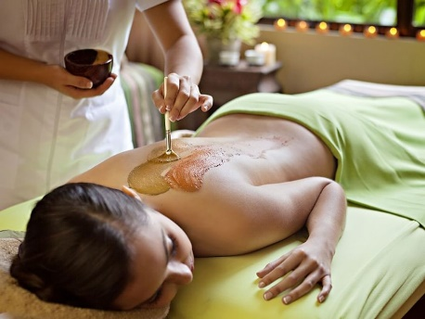
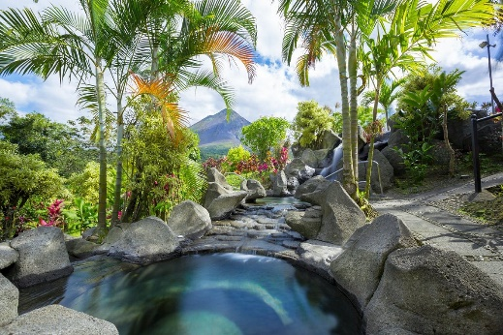
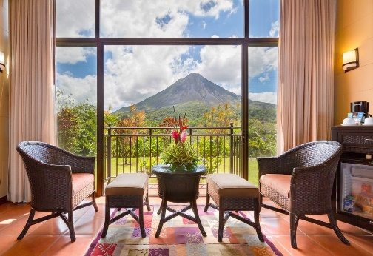

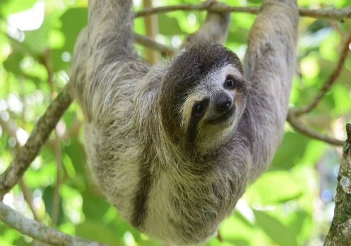
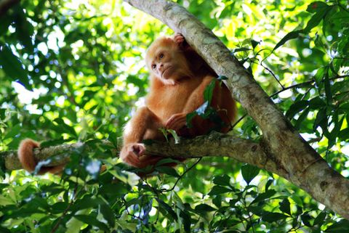
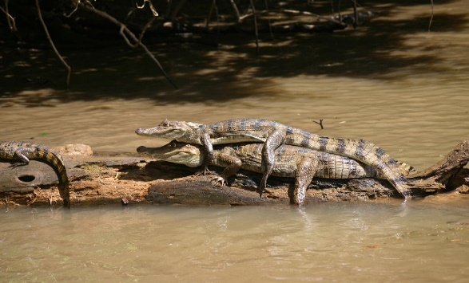
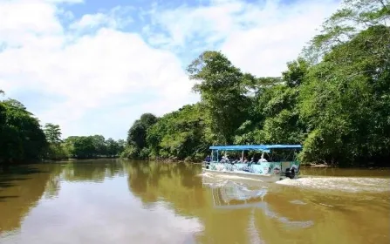
In between the workshops we will visit a plantation rich in Costa Rica culture and history where we will make our own chocolate from sacred cacao rich in antioxidants and sample delicious local coffee and treats. Next, we will take a boat ride down the Frio River part of the Caño Negro Wildlife Refuge. Along the river it is possible to observe a great quantity of birds like the snake-bird, herons, cormorants and animals such as: howler, spider or even white face monkeys, three-toed sloth’s and some reptiles like caimans and turtles.
3 nights Kiora Springs Resort, workshop, breakfast, 2 dinners, 1 lunch and all tours, and transportations included
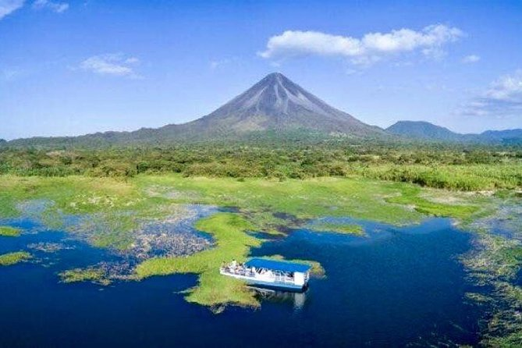
Next, we will cross the beautiful Arenal Lake by boat, then stop at some special spots including a beautiful waterfall as we head to our tranquil and relaxing hotel with breath taking views of the Monteverde Cloud Forest. Monteverde Hotel is walking distance from town filled with restaurants, shops and fun, but you will feel like you have escaped civilization in this oasis surrounded by designer gardens and a private cloud forest reserve teeming with exotic local wildlife. Here we will go above the canopy of the cloud forest on a sky tram, take a walk crossing several swinging bridges as we experience the raw nature of Costa Rica, you have the option of experiencing 1.7 miles of zipline if you would like. We will tap deep into the heartbeat of Costa Rica as we explore the secret spots in Monteverde’s mysterious forests, inviting you to view exotic birds, slumbering sloths and delicate orchids. Here we will tap into the diverse eco systems of the cloud forest where many of our medicinal plants are found.
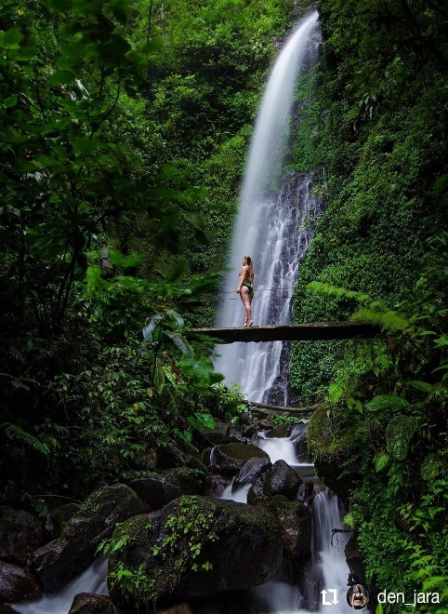
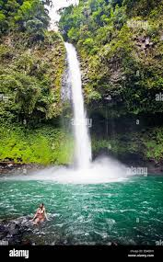
La Fortuna Waterfall El Tigre Waterfall Lake Arenal with views of Volcano

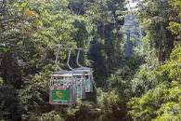
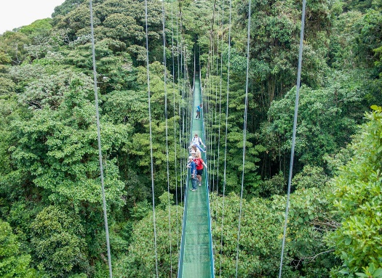
2 Nights at beautiful Monteverde Garden Lodge where you can relax in the spa or take a walk through their designer garden or trails through the reserve. We will experience the mysterious cloud forest by sky tram and then zipline, flying through the top of the canopy, If the zipline is not your thing then take a walk over the canopy by foot and swinging bridges. Here we will also enjoy a night walk seeing the nocturnal beings of the night.
2 Nights Monteverde Garden Lodge, Breakfast, Canopy Tour with Zipline, Night walk, Transports and Boat ride
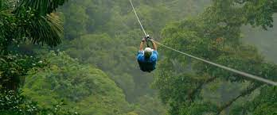
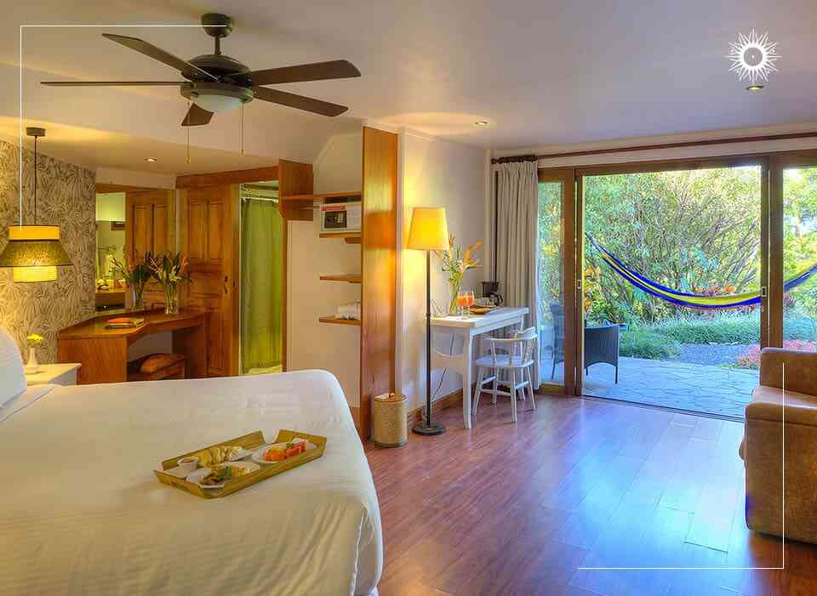
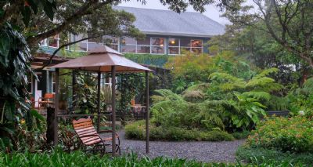
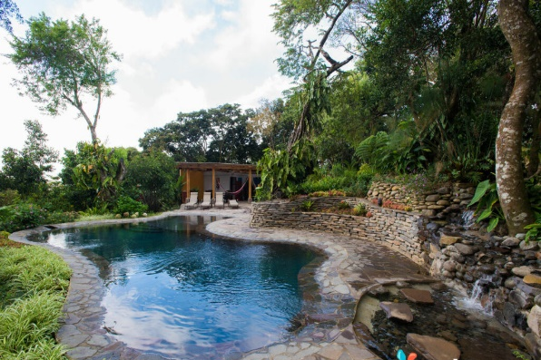
Next, we will head to the coast where we will visit a Waterfall, a monkey sanctuary, (where you will see wild monkeys in their habitat), famous Tarcoles and a walk on the crocodile bridge, Stopping for a yummy fruit smoothie and souvenirs on the way.
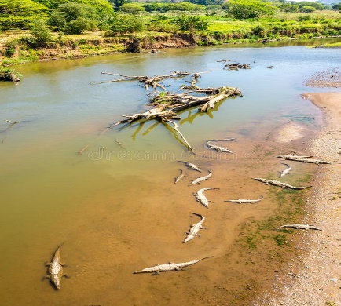
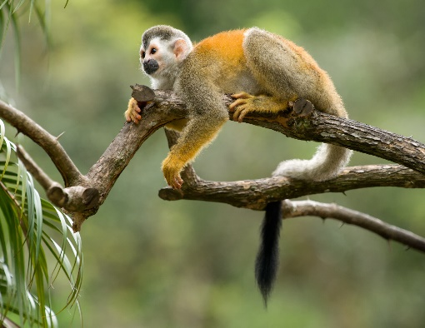
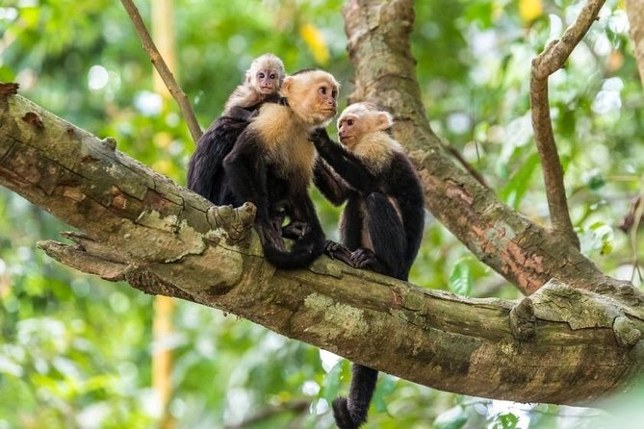

We will spend 3 nights in a house on the ocean in El Roble, Puntarenas area where you can relax by the pool or explore 100 yards further to the beach. We will have our own private chef that will cook whatever you want with plenty of fresh juices or smoothies, snacks and meals. Here we will have a sacred Cocoa Ceremony and meditation, time to relax or go into town to shop or explore on your own. If you are adventurous, you can take a tour of Tortuga Island to snorkel or one of the other many tours in area. We will visit La Paz, featuring Five Famous Waterfalls and The Largest Animal Sanctuary in Costa Rica. It is by far the best place to see wildlife in Costa Rica. We will spend the day there having lunch and exploring the flowing white rivers, spectacular waterfalls, birds, butterflies, monkeys, hummingbirds, snakes, felines and frogs.
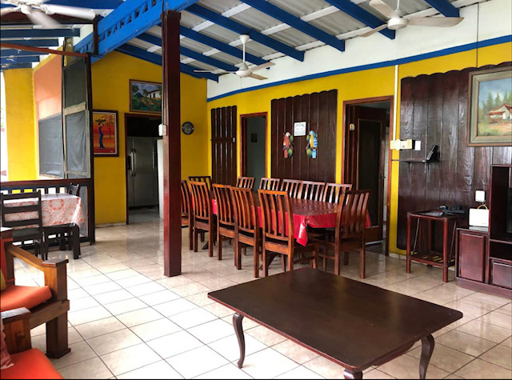
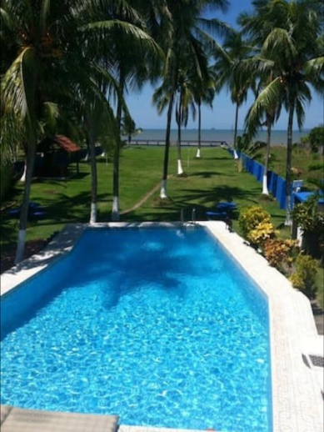
House we will be staying at Outside Hang out area El Roble Town Inside Mall for shopping
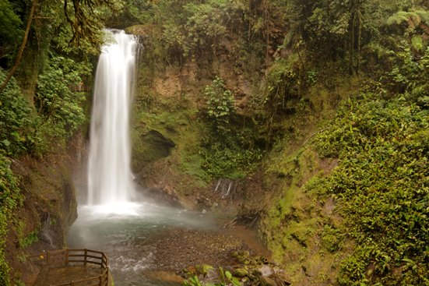
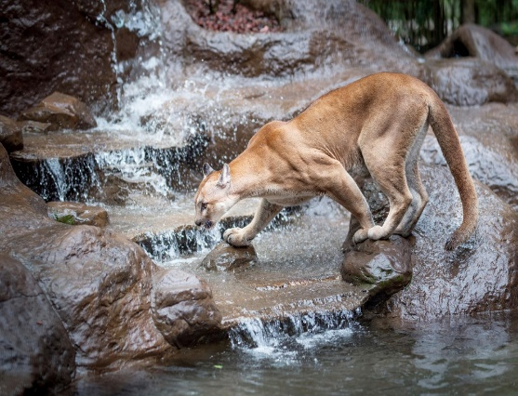
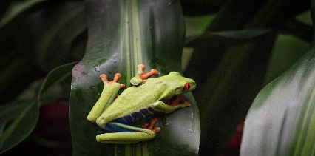

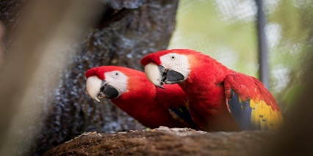

La Paz Waterfall and Animal Sanctuary: Lunch included and time to explore waterfalls or animal habitats on your own
The above trip cost includes: Workshop and meditations, all luxury resorts and accommodations, all breakfast, 5 dinners, 4 lunches, Thermal water entrance to all heated pools on property, including transport and entrance into Titokú Hot Springs. All tours and sanctuary entrances, all transports and boat rides, Sky Tram and zip line, private cook for all meals at house, Sacred Cocoa Ceremony and meditation. Airport Transport both directions.
Price: $2222 from arrival June 18-26th (Airport pickup morning on 18th and airport departure transfer early morning on 26th) Delta, Alaska and United all have great prices leaving on the 17th pdx and arriving morning of 18th or late evening on 17th. There are many hotels right by SJO airport that can have driver pick you up at if come in the night before. I Would like all of the pickups by 9am on the 18th for 11am arrival at our hotel in La Fortuna. If you arrive after that then would have to get separate transfer to the hotel at additional cost.
Extended: From June 26th to 29th Stay at the Asclepios Wellness Spa
A perfect End to our Wellness Retreat for our Body and Soul
Add on: 3 nights at the Asclepios Wellness Spa includes: 3 Organic and bioenergetic meals per day, Participation in daily physical activities (yoga, Pilates or aquafit, according to facilities schedules). Use of the gym and hydrotherapy rooms, which include a natural ionized pool, cold pool and Jacuzzi, and 2 treatments a day. Price for add on is: $1150 2 to a room or $1400 single room. Includes airport transfer
Facility has to enjoy daily:
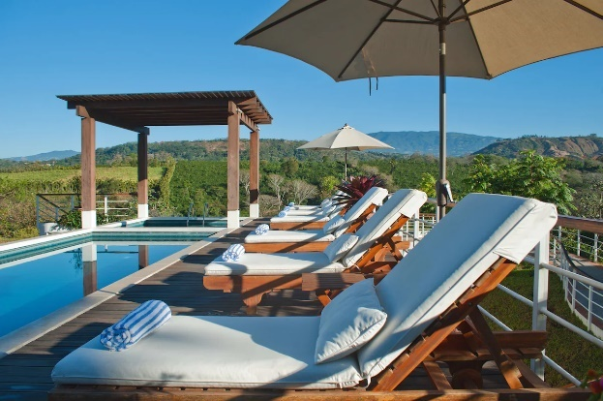
4 outdoor pools
Aerobics classes
Fitness center
Full-service spa
Hiking/biking trails
Horse riding/rentals
Indoor pool
Pilates classes
Sauna
Spa tub
Steam room
Yoga classes
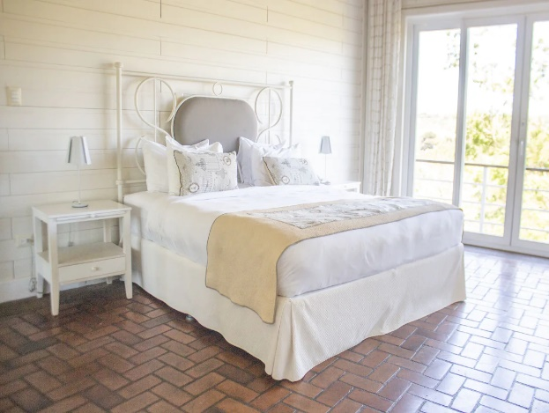
Choose Two Sessions a Day of Below:
1 Royal Chill CBD massage
1 Reiki session
1 Crystal Healing infused essential oil massage
1 Flotation salt session
1 Sauna sessions and rest
1 Hammam session (Turkish steam bath)
1 Tranquillity pro-sleep massage
1 Facial
1 Body Wrap and Vichy shower

You can add on any Extra that you want just let me know so I can book it. Including Tours in area or Horseback Riding. Please see site to add on any extras and costs: https://asclepioscr.com/services-page/.

